

ASSET VERIFICATION AND RECORDING TOOL KIT


Plot 31, Bukoto Street
P.O Box 7657, Kampala, Uganda
+256 (0) 39 2000216/0772525235
email: cpa@cpa.ug

www.cpa.com

August to September 2026

VERIFICATION DETAILS

NAME OF THE REGION: | GREATER MASAKA
SUB-REGION:
Name of Local Government | LYANTONDE DISTRICT LOCAL GOVERNMENT
VERIFIER PARTICULARS
Full name | NANTUMBWE PENINAH/NASSALI VICTORIA K
Contact/ email and Telephone | 0704321431/0760349649
Supervisor/ Sub team leader
Name | KALYOWA LAWRENCE
Contact | 0774106047
Date of submission

HEALTH CENTRES
INFORMANT INTERVIEW/DISCUSSION GUIDE (INCHARGE OR RESPONSIBLE PERSON)

Name of Health Centre: KABATEMERE HEALTH CENTRE III

1a | Does the Facility have a record of all assets provided under UgIFT.  (Obtain a record and verify if it has the costs and numbers supplied | Yes
1b | If Not ask how many were supplied and when.

2 | How does this facility Maintain (repair/service/replace) the assets provided under Ugift

They get funds

3 | Does the facility take regular record about functionality/ or breakdown of the assets provided? | Yes

4 | How has the UgIFT support helped in service delivery in the area, any issues, challenges and any recommendations for better program implementation.

Challenges
- They don’t know how to use the equipments
- They lack professional nurses and doctors.
- Some equipments come incomplete
- Lack experience while treating the patients.

PROCEED TO VERIFICATION AFTER THIS DISCUSSION

Recommendations

- Getting new nurses and doctors for the healthy facility
- Getting a person to teach the people who are supposed to use such item

Health centre checklist

NAME OF LG: LYANTONDE DISTRICT LOCAL GOVERNMENT NAME OF HEALTH FACILITY: KABETEMERE H/C III

Equipment/ Item | Department | Asset Number | Item  Description | Life in Months | Tag Number ( engrave no.) | Date Of Purchase | Date Placed In Service | Recoverable cost | Cost | Acc Dep Cost | Net Book Value | Ytd Deprn | Equipment status | Remarks
B.P. Machine, Digital | OPD |  | Received 1 white in colour |  | Not engraved | 29/11/23 | 30/11/23 |  |  |  |  |  | Functional | Functional
B.P. Machine (Aneroid wall mounted) | OPD |  | Received 1 white in colour with black metallic base |  | Not engraved | 29/11/23 | 30/11/23 |  |  |  |  |  | Functional | Functional
Autoclave 20 Liters.,Duo Operated | OPD |  | It received 2 but not verified |  |  | 29/11/23 | 30/11/23 |  |  |  |  |  | Functional | Functional
Bowl, Kick | OPD |  | It was 1 but not verified |  |  | 29/11/23 | 30/11/23 |  |  |  |  |  | Functional | Functional
Bowl Stand | OPD |  | It was 1 but not seen |  |  | 29/11/23 | 30/11/23 |  |  |  |  |  | Functional | Functional
Counting chamber Neubauer- Improved | OPD |  | They were 2 but not verified. |  |  | 29/11/23 | 30/11/23 |  |  |  |  |  | Functional | Functional
Cupboard Steel, Lockable | OPD |  | They received 3 grey in colour with compartments |  | Not engraved | 29/11/23 | 30/11/23 |  |  |  |  |  | Functional | Functional
Drip Stand | OPD |  | Received 15, they have 5 wheels with a straight vertical stand with locks |  | Not engraved | 29/11/23 | 30/11/23 |  |  |  |  |  | Functional | Functional
ESR Stand | OPD |  | Received 1 but not verified |  |  | 29/11/23 | 30/11/23 |  |  |  |  |  | Good condition | Packed
Examination Couch | OPD |  | Received 1 with 4 silver stands with black soft sponge mattress with a lifter |  | Not engraved | 29/11/23 | 30/11/23 |  |  |  |  |  | Good condition | Packed
Examination light,LED | Maternity OPD |  | They received 3 but not seen |  |  | 29/11/23 | 30/11/23 |  |  |  |  |  | Good condition | Packed
Glucometer | OPD |  | It was 1 white in colour with strip tin without a flicker |  | Not engraved | 29/11/23 | 30/11/23 |  |  |  |  |  | Good condition | Packed
Haemoglobin Meter, Digital | OPD |  | They received 2 white in colour with 3 buttons and a square screen |  | Not engraved | 29/11/23 | 30/11/23 |  |  |  |  |  | Good condition | Packed
Height Meter | OPD |  | They were 2 but not verified |  |  | 29/11/23 | 30/11/23 |  |  |  |  |  | Good condition | Packed
Instrument Trolley | OPD |  | They were 2 silver in colour and 4 black wheels |  | Not engraved |  |  |  |  |  |  |  | Good condition | Packed
Microscope Binocular | OPD |  | It was 1 white and black in colour |  | Not engraved | 29/11/23 | 30/11/23 |  |  |  |  |  | Good condition | Packed
Otoscope | OPD |  | Received 1 silver and black in colour |  | Not engraved | 29/11/23 | 30/11/23 |  |  |  |  |  | Good condition | Packed
Patient Screen | OPD |  | They received 3 silver stand with a blue cross |  | Not engraved | 29/11/23 | 30/11/23 |  |  |  |  |  | Good condition | Packed
Patient Trolley | OPD |  | They received 1 with 4 wheels with a black soft mattress |  | Not engraved | 29/11/23 | 30/11/23 |  |  |  |  |  | Good condition | Packed
Refrigerator, Basic | Maternity LAB |  | It was 2 grey in colour |  | Not engraved | 29/11/23 | 30/11/23 |  |  |  |  |  | Good condition | Functional
Stethoscope | OPD |  | They received 4 black in colour with 2 rubber tubes |  | Not engraved | 29/11/23 | 30/11/23 |  |  |  |  |  | Good condition | Functional
Stop Watch | OPD |  | They received 1 but not seen |  |  | 29/11/23 | 30/11/23 |  |  |  |  |  | Good condition | Functional
Stretcher | OPD |  | They received 2 with 4 black wheels with a soft bed |  | Not engraved | 29/11/23 | 30/11/23 |  |  |  |  |  | Good condition | Functional
Stove, Gas | OPD |  | White in colour, 6 kilos stabex |  | Not engraved | 29/11/23 | 30/11/23 |  |  |  |  |  | Good condition | Functional
Weighing Scale with Height Meter, Adult |  |  | They received 3 white in colour with automated white and garage |  | Not engraved | 29/11/23 | 30/11/23 |  |  |  |  |  | Good condition | Functional
Weighing Scale, Infant | Maternity |  | It was 1 but not seen |  |  | 29/11/23 | 30/11/23 |  |  |  |  |  | Good condition | Functional
Weighing Scale, Toddler | Maternity |  | They 2 but not seen |  |  | 29/11/23 | 30/11/23 |  |  |  |  |  | Good condition | Functional
Wheel Chair |  |  | They received 3 with 4 wheels with 2 pads in black |  | Not engraved | 29/11/23 | 30/11/23 |  |  |  |  |  | Good condition | Functional
Audio Visual Equipment
Medical Waste Bin | Maternity |  | They received 15 silver in colour wrapped with polythene bags |  | Not engraved | 29/11/23 | 30/11/23 |  |  |  |  |  | Good condition | Functional
Wall Clock |  |  | They received 3 round and white in colour with figures |  | Not | 29/11/23 | 30/11/23 |  |  |  |  |  | Good condition | Non-Functional
Diagnostic Equipment Set for MCH | MCH |  | Not verified |  |  | 29/11/23 | 30/11/23 |  |  |  |  |  | Good condition | Functional
Diagnostic Equipment Set for OPD | OPD |  | Not verified |  |  | 29/11/23 | 30/11/23 |  |  |  |  |  | Good condition | Functional
Glassware Set, Laboratory, Basic | LAB |  | Not verified |  |  | 29/11/23 | 30/11/23 |  |  |  |  |  | Good condition | Functional
Hollow Ware Set, Treatment | OPD |  | Not verified |  |  | 29/11/23 | 30/11/23 |  |  |  |  |  | Good condition | Functional
Instrument Set, Dressing | OPD |  | Not verified |  |  | 29/11/23 | 30/11/23 |  |  |  |  |  | Good condition | Functional
Instrument Set, Basic ENT | OPD |  | Not verified |  |  | 29/11/23 | 30/11/23 |  |  |  |  |  | Good condition | Functional
Instrument Set, Suture | OPD |  | Not verified |  |  | 29/11/23 | 30/11/23 |  |  |  |  |  | Good condition | Functional
Pulse Oximeter, Hand held | OPD |  | Not verified |  |  | 29/11/23 | 30/11/23 |  |  |  |  |  | Good condition | Functional
Bed, Adult Patient with Mattress | OPD |  | They received 20 beds silver in colour with a black soft mattress |  | Not engraved |  |  |  |  |  |  |  |  | Didn’t receive
Bed, Pediatric Patient, With Mattress |  |  | They received 4 beds with white and black mattress. |  | Not engraved
Bedside Locker | OPD |  | They received 10 lockers with 2 compartments |  | Not engraved | 29/11/23 | 30/11/23 |  |  |  |  |  | Good condition | Functional
Cupboard, Instrument |  |  | They were 5 but not verified
Delivery Bed, Hydraulic Manual | Maternity |  | It was 1 with a blue mattress with a drip |  | KBT.MOH/23/DD/01 | 29/11/23 | 30/11/23 |  |  |  |  |  | Good condition | Functional
Oxygen Therapy Apparatus, Mininum 45L cylinder | Maternity |  | It was one but not verified |  |  |  |  |  |  |  |  |  |  | They have apparatus but don’t have a cylinder
Resuscitator Manual, Infant, with all Mask sizes | MOH |  | It was 1 but not verified |  |  | 29/11/23 | 30/11/23 |  |  |  |  |  | Good condition | Functional
Resuscitator Manual, Adult, with all mask sizes | MOH |  | They were 1 but not verified |  |  | 29/11/23 | 30/11/23 |  |  |  |  |  | Good condition | Functional
Suction Apparatus, (Electric) | Maternity |  | It was one with 1 white bags of water |  | Not engraved | 29/11/23 | 30/11/23 |  |  |  |  |  | Good condition | Functional
Nebulizer, Ultrasonic | Maternity |  | It was 10 but not seen |  |  | 29/11/23 | 30/11/23 |  |  |  |  |  | Good condition | Functional
Oxygen Concentrator, Duo Flow | OPD |  | It was 1 with grey 2 handles on top and cylinder also on top |  | Not engraved | 29/11/23 | 30/11/23 |  |  |  |  |  | Good condition | Functional
Bench |  |  | They were 5 with brown soft sponge with brown wooden stands |  | Not engraved | 29/11/23 | 30/11/23 |  |  |  |  |  | Good condition | Functional
Disinfection Buckets | Maternity |  | They were 7 normal buckets with different colours |  | Not engraved | 29/11/23 | 30/11/23 |  |  |  |  |  | Good condition | Functional
Baby Cot | MOH |  | They were 2 silver in colour, rectangular with rails |  | Not engraved | 29/11/23 | 30/11/23 |  |  |  |  |  | Good condition | Functional
Diagnostic Equipment Set for Ward | MOH |  | They were 2 but not seen |  |  | 29/11/23 | 30/11/23 |  |  |  |  |  | Good condition | Functional
Hollow Ware Set, Ward | MOH |  | They were 2 but not verified. |  |  | 29/11/23 | 30/11/23 |  |  |  |  |  | Good condition | Functional
Instrument Set, Delivery | MOH |  | They were 5 but not verified. |  |  | 29/11/23 | 30/11/23 |  |  |  |  |  | Good condition | Functional
Instrument Set, Stitch Removing | MOH |  | They were 5 but not verified. |  |  | 29/11/23 | 30/11/23 |  |  |  |  |  | Good condition | Functional
MVA Kit | MOH |  | They were 5 but not verified |  |  | 29/11/23 | 30/11/23 |  |  |  |  |  | Good condition | Functional
Stool, Laboratory | LAB |  | They were 3 black in colour |  | Not engraved | 29/11/23 | 30/11/23 |  |  |  |  |  | Good condition | Functional
Penguin Sucker | MOH |  | They were 3 rubber in nature |  | Not engraved | 29/11/23 | 30/11/23 |  |  |  |  |  | Good condition | Functional
Fetoscope, Dopplar | MOH |  | They were 10 silver in nature, cylindrical with a round top on base |  | Not engraved | 29/11/23 | 30/11/23 |  |  |  |  |  | Good condition | Functional
Bubble CPAP
Centrifuge (Electric) | MOH |  | It was one but not seen |  |  | 29/11/23 | 30/11/23 |  |  |  |  |  | Good condition | Functional
Kangaroo Mother Care Chair | MOH |  | It was 1 with four wheels with a brown soft sponge |  | Not engraved | 29/11/23 | 30/11/23 |  |  |  |  |  | Good condition | Functional
Radiant Infant Warmer |  |  | They were 2 but not seen
Haemoglobin Meter, Sahli | MOH |  | They were 2 but not seen |  |  | 29/11/23 | 30/11/23 |  |  |  |  |  | Good condition | Functional
Delivery Bed | MOH |  | It was 1 with a black mattress |  | Not engraved | 29/11/23 | 30/11/23 |  |  |  |  |  | Good condition | Functional
Examination light | MOH |  | They were 2 with a bulb on top with 5 wheels |  | Not engraved | 29/11/23 | 30/11/23 |  |  |  |  |  | Good condition | Functional
Instrument set, ENT Basic for HCIII | MOH |  | It was 1 but not verified |  |  | 29/11/23 | 30/11/23 |  |  |  |  |  | Good condition | Functional
Bag Valve mask (Ambu Bag), Neonatal | MOH |  | They were 14 with white yellow valve and a glass with white masks |  | Not engraved | 29/11/23 | 30/11/23 |  |  |  |  |  | Good condition | Functional
Incubator
Office Chair | Office |  | They were 9 black in colour swinging in nature |  | Not engraved | 29/11/23 | 30/11/23 |  |  |  |  |  | Good condition | Functional
Desk | OPD |  | They were 5 brown in colour |  | Not engraved | 29/11/23 | 30/11/23 |  |  |  |  |  | Good condition | Functional
Filing Cabinet | OPD |  | They were 4 but not verified. |  |  | 29/11/23 | 30/11/23 |  |  |  |  |  | Good condition | Functional
Non Residential Buildings
Residential Buildings |  |  | It was 1 room in one block |  | Not engraved | 29/11/23 | 30/11/23 |  |  |  |  |  | Good condition | Functional
Baby coat

SCHOOL VERIFICATION CHECKLIST

SCHOOL INTERVIEW/DISCUSSION GUIDE

Name of school: RWAMABARA SEED SECONDARY SCHOOL

1a | Does the Facility have a record of all assets provided under UgIFT.  (Obtain a record and verify if it has the costs and numbers supplied | NO
1b | If Not ask how many were supplied and when. | By writing somewhere

2 | How does this facility Maintain (repair/service/replace) the assets provided under Ugift

They get funds for repair and maintenance

3 | Does the facility take regular record about functionality/ or breakdown of the assets provided?  Nonfunctional/ working, and reasons for non-functionality. | Yes

4 | How has the UgIFT support helped in service delivery in the area, any issues, challenges and any recommendations for better program implementation.

Challenges
- Lack of professional teachers
- Lack of more classrooms
- Desks and comuters are few compared to the number of students

Recommendations
- They need more teacher
- They need more classroom blocks
- They need more equipment

PROCEED TO VERIFICATION AFTER THIS DISCUSSION

SCHOOL FURNITURE
(School Desks, Office chairs, Laboratory stools, Book shelves)

Name of LGLYANTONDE DISTRICT LOCAL GOVERNMENT Name of SCHOOL: RWAMABARA C.O.U SECONDARY SCHOOL

Equipment/ Item | Department | Asset Number | Item  Description | Life in Months | Tag Number ( engrave no.) | Date Of Pur | Date Placed In Service | Recoverable cost | Cost | Acc Dep Cost | Net Book Value | Ytd Deprn | Equipment status | Remarks
Desks | Education | 120 | Metal wooden | 72 | Not  engraved |  |  |  |  |  |  |  | Good condition | Functional
Stools | Education | 192 | Wooden metal | 72 | Not  engraved |  |  |  |  |  |  |  | Good condition | Functional
Tables | Education | 117 | Wooden | 72 | Not  engraved |  |  |  |  |  |  |  | Good condition | Functional
Chairs | Education | 20 | metal | 72 | Not  engraved |  |  |  |  |  |  |  | Good condition | Functional

ICT ITEMS TO VERIFY
(Desktop Computer, Server Processor, Network Switch 24 Port, Multipurpose Printer, UPS, Projector, Air Conditioners, Server, CCTV Camera)

Name of LG: LYANTONDE DISTRICT LOCAL GOVERNMENT Name of SCHOOL: RWAMABARA SEED SECONDARY SCHOOL

Equipment/ Item | Department | Asset Number | Item  Description | Life in Months | Tag Number ( engrave no.) | Date Of Pur | Date Placed In Service | Recoverable cost | Cost | Acc Dep Cost | Net Book Value | Ytd Deprn | Equipment status | Remarks
Desktop computer | Education |  | They received  24  Black in colour | 52 | Not  engraved |  | 17/6/2021 |  |  |  |  |  | Good condition | Functional
Air conditioner | Education |  | It was 1 still  packed | 52 | Not  engraved |  | 17/6/2021 |  |  |  |  |  | Good condition | Functional
Projector | Education |  | It was 1 still  packed | 52 | Not  engraved |  | 17/6/2021 |  |  |  |  |  | Good condition | Functional
Printer | Education |  | It was white in  Colour.  Received  1 | 52 | Not  engraved |  | 17/6/2021 |  |  |  |  |  | Good condition | Functional

BUILDINGS TO VERIFY
(Non- Residential and Residential, Kitchen, Toilets/Pit latrine Water tanks, Fences etc.)

Name of LG LYANTONDE DISTRICT LOCAL GOVERNMENT Name of SCHOOL: RWAMABARA SEED SECONDARY SCHOOL

Equipment/ Item | Department | Asset Number | Item  Description | Life in Months | Tag Number ( engrave no.) | Date Of Pur | Date Placed In Service | Recoverable cost | Cost | Acc Dep Cost | Net Book Value | Ytd Deprn | Equipment status | Remarks
Classroom | Education |  | They are 3 blocks with 2 classrooms each | 91 | Not engraved |  |  |  |  |  |  |  | Good condition | Functional
Multipurpose hall | Education |  | It was 1 block with a main hall | 91 | Not engraved |  |  |  |  |  |  |  | Good condition | Functional
Administration block | Education |  | It was 1 block with office and staffroom | 91 | Not engraved |  |  |  |  |  |  |  | Good condition | Functional
Computer and library | Education |  | It was 1 block with ICT and library shared | 91 | Not engraved |  |  |  |  |  |  |  | Good condition | Functional
Staff block | Education |  | They received 3 blocks with 2 rooms each | 91 | Not engraved |  |  |  |  |  |  |  | Good condition | Functional
Science lab | Education |  | It was 1 block shared with all science subjects | 91 | Not engraved |  |  |  |  |  |  |  | Good condition | Functional
Play ground | Education |  | It is 1 pitch large and big | 91 | Not engraved |  |  |  |  |  |  |  | Good condition | Functional
Toilets | Education |  | They are 5 blocks 3 rooms each | 91 | Not engraved |  |  |  |  |  |  |  | Good condition | Functional
Water tanks | Education |  | They are 3 black in colour different litres | 60 | Not engraved |  |  |  |  |  |  |  | Good condition | Functional
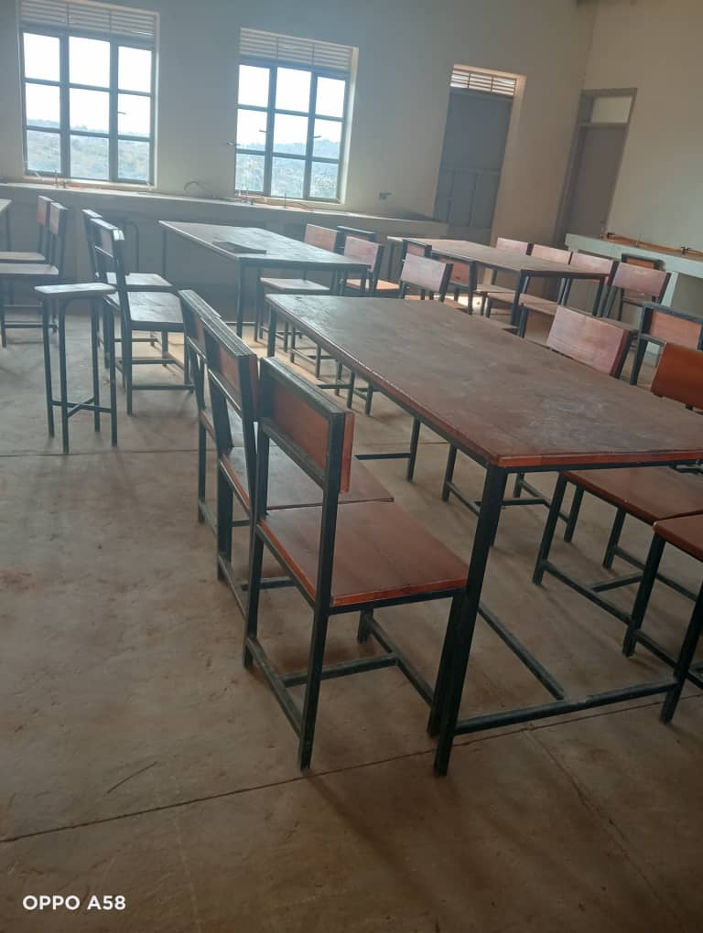
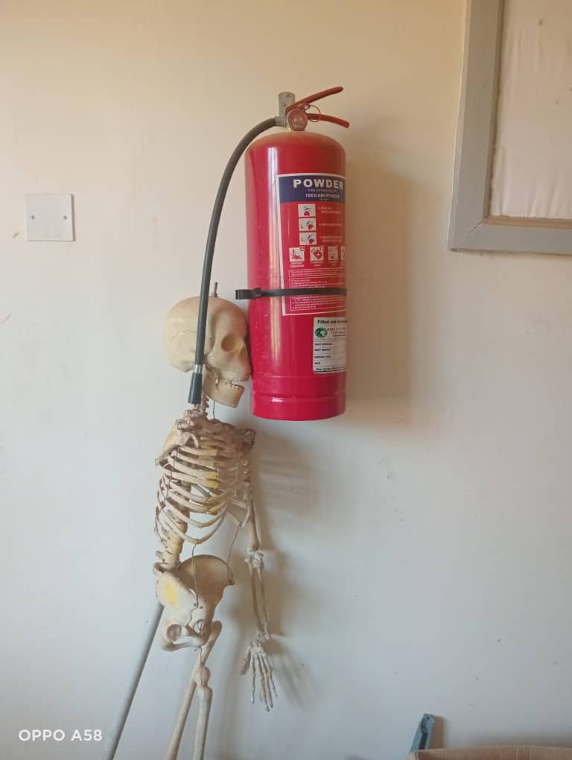
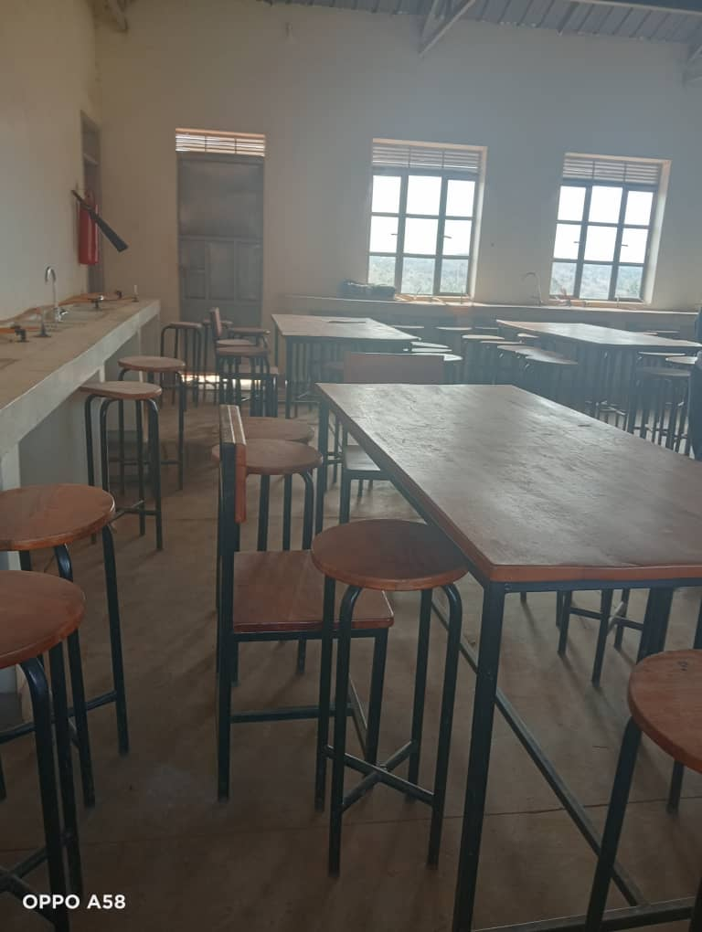
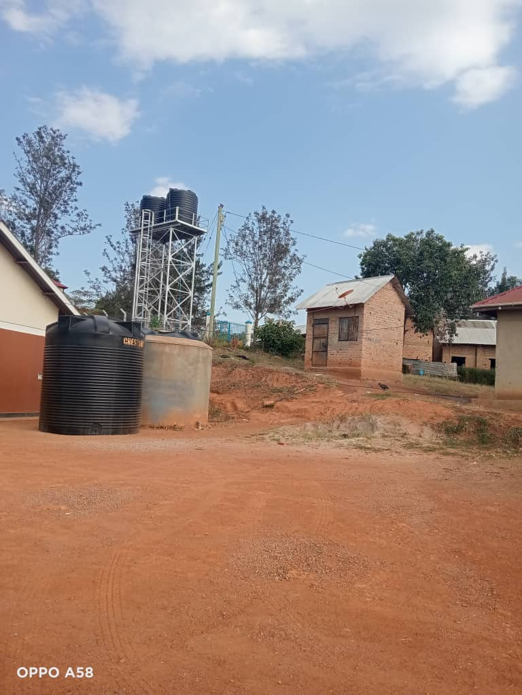

Tanks Lab Fire extinguisher Library area

ICT Block Classrooms Library
